**Introduction to Programming & Python**

### **📌 What is Programming? (Concepts & Importance)**

### **🔹 1. Definition of Programming**

Programming is the process of **giving instructions** to a computer to perform a specific task. It involves **writing, testing, and debugging** code in a programming language like Python, Java, or C++.

### **🔹 2. Why is Programming Important?**

✅ **Automation** – Reduces manual work by automating repetitive tasks  
 ✅ **Data Processing** – Used in data analysis, AI, and machine learning  
 ✅ **Software Development** – Builds applications (web, mobile, desktop)  
 ✅ **Problem-Solving** – Helps in logical thinking and structuring solutions  
 ✅ **IoT & Robotics** – Used in smart devices and robotics development

### **🔹 3. How Does a Computer Understand Programs?**

Computers only understand **binary (0s and 1s)**. Programming languages act as a **bridge** between **humans and machines**.

* **High-level languages** (Python, Java, C++) → Easy for humans to write
* **Low-level languages** (Assembly, Machine Code) → Close to hardware

**🆚 Difference Between Coding & Programming**

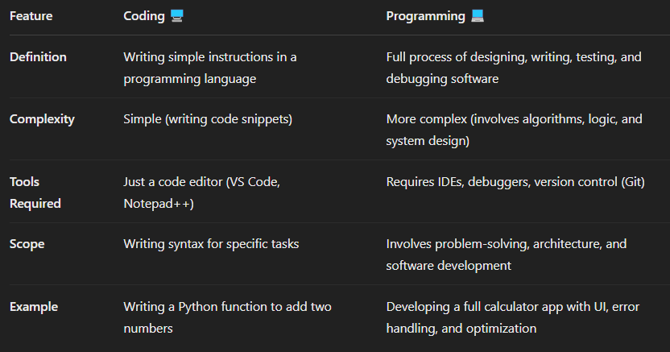

### **📝 Key Takeaways**

✔ Coding is a part of Programming  
 ✔ Programming includes problem-solving, designing, and debugging  
 ✔ A good programmer knows both coding & software development concepts

## **Types of Programming Paradigms**

Programming languages follow different paradigms (styles of programming) based on how they solve problems. Here are the major types:

### **1️⃣ Procedural Programming**

🔹 Definition: Uses step-by-step instructions (procedures) to solve problems.  
 🔹 Example Languages: C, Pascal, Python (supports procedural style)  
 🔹 Key Features:  
 ✅ Follows a top-down approach  
 ✅ Uses functions (procedures) to divide code  
 ✅ Easy to read and understand

**🔹 Where is it Used?**

* Small programs
* Simple automation scripts

### **2️⃣ Object-Oriented Programming (OOP)**

🔹 Definition: Organizes code into objects (real-world entities) with properties and methods.  
 🔹 Example Languages: Python, Java, C++, C#  
 🔹 Key Features:  
 ✅ Uses classes and objects  
 ✅ Supports Encapsulation, Inheritance, Polymorphism, Abstraction  
 ✅ Best for scalable and reusable code

**🔹 Example in Python:**

**🔹 Where is it Used?**

* Large applications
* Web development
* Game development

### **3️⃣ Functional Programming**

🔹 **Definition:** Treats computation as the evaluation of mathematical functions and avoids changing state.  
 🔹 **Example Languages:** Python, Haskell, Lisp, Scala  
 🔹 **Key Features:** ✅ Uses **pure functions** (no side effects)  
 ✅ Supports **higher-order functions** (map(), filter(), reduce())  
 ✅ Good for **parallel computing**

🔹 **Where is it Used?**

* Data processing (Pandas, PySpark)
* AI and ML applications

### **Functional Programming (FP) vs Object-Oriented Programming (OOP) – Technical Differences**

1️⃣ **State Management**

* **OOP** → Uses objects that store data (stateful). Example: A BankAccount class with a balance that updates.
* **FP** → No stored state, only pure functions. Example: A function that calculates interest without modifying the balance.

2️⃣ **Mutability vs Immutability**

* **OOP** → Objects are mutable (can be modified).
* **FP** → Data is immutable; changes return new data instead of modifying existing ones.

3️⃣ **Concurrency & Parallelism**

* **OOP** → Shared states can lead to race conditions (requires locks & synchronization).
* **FP** → No shared state, making it **better for parallel processing** (e.g., Spark, Dask).

4️⃣ **Code Structure**

* **OOP** → Organizes code using **classes and objects** with methods.
* **FP** → Uses **pure functions** that take input and return output without side effects.

5️⃣ **Reusability & Testing**

* **OOP** → Testing is harder due to dependencies between objects.
* **FP** → Easier to test as functions are independent and don’t depend on object state.

### **When to Use What?**

✅ **Use OOP** for applications with long-lived objects (e.g., web apps, games).  
 ✅ **Use FP** for **data transformations, parallel computing, and big data processing** (e.g., Pandas, PySpark).

**How is FP Different from OOP?**

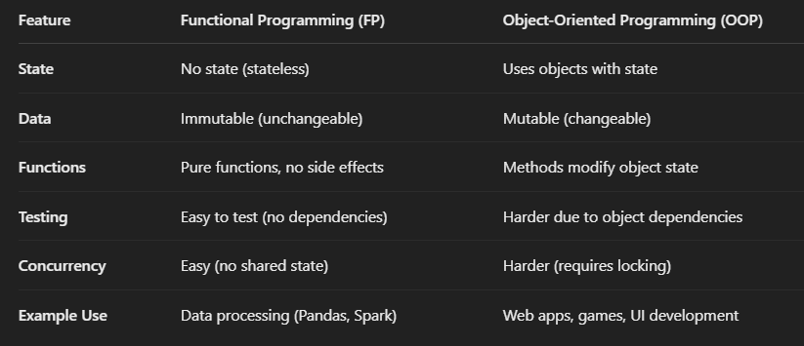

### **Conclusion**

**✅ Use FP for data transformations, analytics, machine learning, and parallel computing.  
 ✅ Use OOP for building applications, user interfaces, and complex systems.**

**✅ Here are some popular languages, platforms, and tools developed using Python:**

### **🔹 1. YouTube (Initial Prototype)**

* The early version of YouTube was developed using Python.
* Even today, Python is used in parts of YouTube's backend for automation and data.

### **🔹 2. Instagram**

* Instagram's backend is heavily powered by Python + Django.
* It handles billions of users and photos using Python.

### **🔹 3. Dropbox**

* Dropbox's desktop client and server-side code are written in Python.
* Even the founder, Guido van Rossum (creator of Python), worked at Dropbox.

### **🔹 4. Reddit**

* Originally written in Lisp, then moved to Python for scalability and ease of development.

### **🔹 5. BitTorrent**

* The peer-to-peer file sharing protocol BitTorrent was initially created using Python.

### **🔹 6. OpenStack**

* A popular cloud computing platform used by many enterprises — mostly written in Python.

### **🔹 7. Blender (Scripting Language)**

* The 3D modeling and animation software Blender uses Python for scripting and automation.

### **🔹 8. Ansible**

* A powerful infrastructure automation tool, written in Python.

### **🔹 9. TensorFlow (Some parts)**

* While TensorFlow is mainly in C++, it has a Python API, and many training scripts are written in Python.

### **🔹 10. Pip, Flask, Django, Pandas, NumPy, etc.**

* All these Python frameworks and libraries are, of course, developed in Python.

## **✅ Languages Developed in Python (Extended List)**

## **1) Hy**

* What Is It? A Lisp dialect that compiles to Python’s Abstract Syntax Tree (AST).
* Key Point: You can mix Lisp code with Python libraries, making it easy to use Lisp features (macros, s-expressions) alongside the entire Python ecosystem.

## **2) Coconut**

* What Is It? A functional programming superset of Python.
* Key Point: Coconut adds pattern matching, lazy lists, and other functional features, then compiles down to standard Python code.
* Usage: Great if you want Haskell-like features in a Python-based project.

## **3) MyHDL**

* What Is It? A hardware description language (HDL) built in Python.
* Key Point: Instead of using VHDL or Verilog, you can describe hardware logic in Python (MyHDL). It translates your Python code into Verilog or VHDL for actual circuit synthesis.

### 

### 

### **Why Are They Built in Python?**

1. Easy to Parse & Transform: Python has powerful libraries for parsing, AST manipulation, and code generation.
2. Large Ecosystem: They can reuse the entire Python ecosystem (e.g., packaging, tooling, libraries).
3. Rapid Prototyping: Python’s readability and flexibility make it ideal for building new languages or DSLs quickly.

## **✅ Popular Frameworks Developed in Python**

### **🕸️ Web Development**

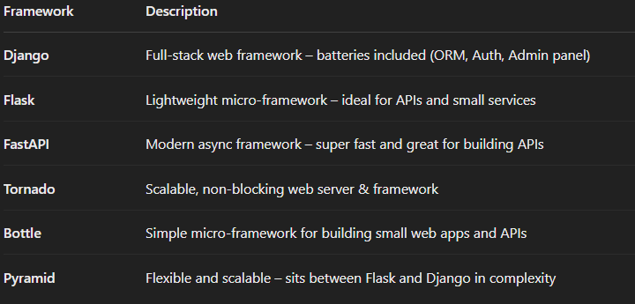

**📊 Data Science / Machine Learning**

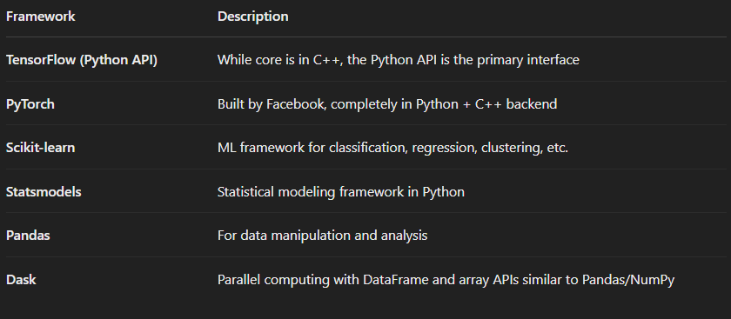

**📦 Web Scraping & Automation**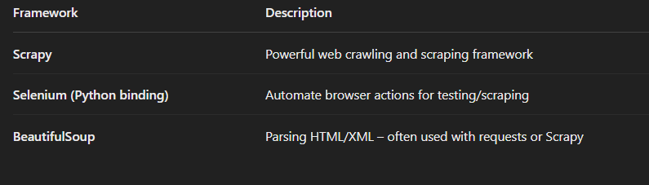

**💻 GUI Development**

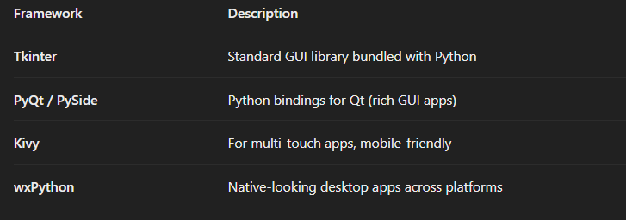

**☁️ Cloud, DevOps, Automation**

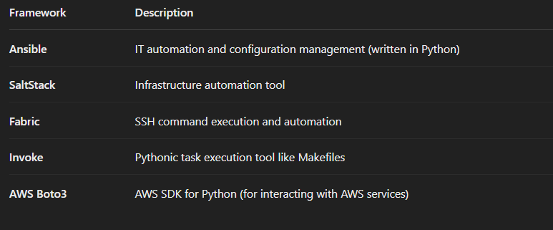

**🧪 Testing**

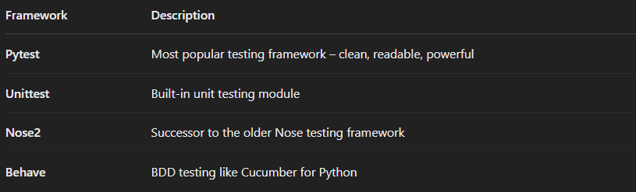

**🛠️ Other Interesting Frameworks**

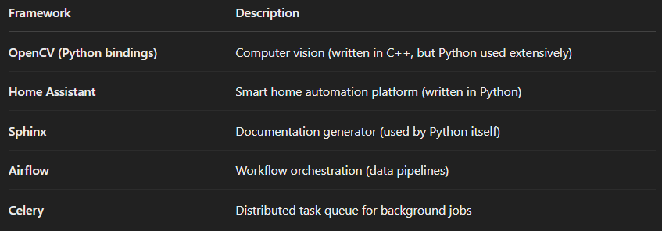

**Python has frameworks in:**

* ✅ Web Dev (Django, Flask, FastAPI)
* ✅ Data Science (PyTorch, Scikit-learn)
* ✅ Automation (Ansible, Airflow)
* ✅ Desktop GUI (Tkinter, PyQt)
* ✅ Testing (Pytest, Unittest)
* ✅ Scraping (Scrapy, BeautifulSoup)

**📝 Python Software Foundation License (PSFL)**

### **🔹 What is PSFL?**

* The Python Software Foundation License is a free and open-source license, approved by both:  
  + OSI (Open Source Initiative)
  + FSF (Free Software Foundation)

**🔹 Key Points of the PSFL:**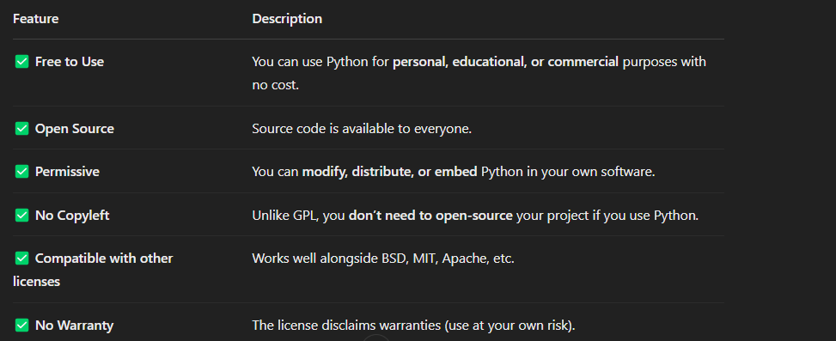

### **🔹 Which version of Python uses this license?**

* Since Python 2.1, the language is licensed under the PSFL.
* Earlier versions (before 2.1) had a license similar to the CNRI license.

### **🔐 Is Python truly “Free”?**

**YES** – Free as in:

* **Free Speech** (freedom to use, change, distribute)
* **Free Beer** (no cost)

### **🚀 Real-World Implication:**

You can:

* Use Python to build apps (even commercial ones)
* Modify the source code of Python itself
* Embed Python in your product
* Distribute your tools without worrying about licensing restrictions

## **📜 Python History in Short**

### **🔹 1991 – Python was born**

* Created by **Guido van Rossum** in the Netherlands.
* First version (**Python 0.9.0**) was released on **February 20, 1991**.
* Inspired by **ABC language** and named after **Monty Python’s Flying Circus** (not the snake! 🐍😂)

## **🐍 Python Compilation Process with PVM**

Python is an **interpreted** language, but it still involves a **compilation step** — just not like C or Java.

Let’s go step-by-step:

### **🔷 Step 1: Writing Code**

You write code in a .py file (example: hello.py)

print("Hello, World!")

### **🔷 Step 2: Compilation to Bytecode (.pyc)**

* When you run your Python script:  
  + Python first **compiles** it to an intermediate code called **bytecode**.
  + This bytecode is saved as a .pyc file in the __pycache__ folder.

hello.py 👉 Compiled to hello.cpython-311.pyc

### **✅ Bytecode is:**

* A **low-level**, platform-independent set of instructions.
* Not human-readable.
* Faster to execute than re-parsing .py files every time.

### **🔷 Step 3: Execution by PVM (Python Virtual Machine)**

* The **PVM** reads the .pyc bytecode and **executes** it line by line.
* It handles:  
  + Memory management
  + Variable storage
  + Function calls
  + Object creation
  + Exception handling

✅ The **PVM is the actual runtime engine** that runs your Python code.

🔷 Visualization:

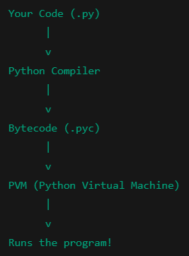

**💡 Key Points:**

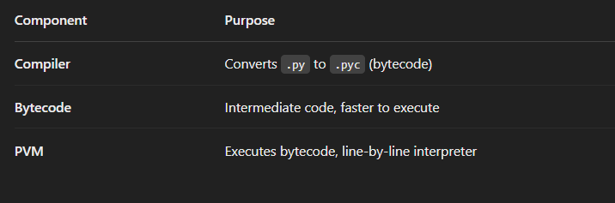

### **❓ Why Not Directly to Machine Code?**

**Because:**

* Python is platform-independent (write once, run anywhere).
* Using bytecode + PVM allows for flexibility and easier debugging.
* Machine code would tie Python to a specific OS/CPU.

### **✅ Summary:**

* Python compiles .py → .pyc (bytecode)
* **PVM** reads and executes bytecode
* This makes Python **interpreted**, but with an internal **compilation step**

### **🔁 Contrast with a Compiled Language (like C):**

In C:

* Entire .c code is **compiled into machine code (.exe)** before running
* Then you run the executable

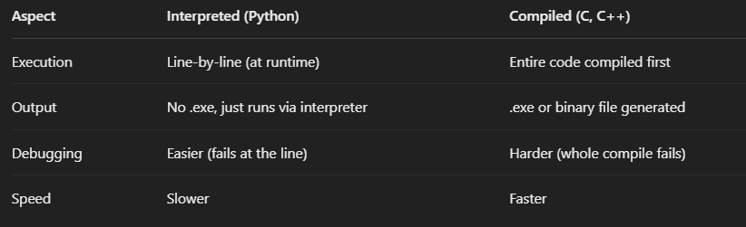

**💡 Why Bytecode?**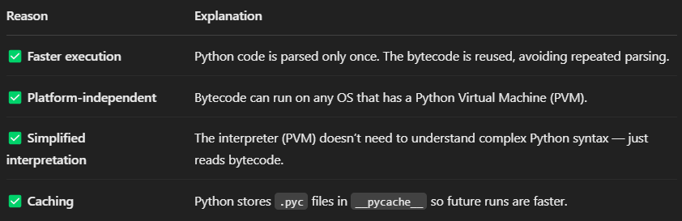

### **🧠 Final Analogy:**

* Python file (.py) = Your original recipe
* Bytecode (.pyc) = The pre-prepared dish
* PVM = The waiter that serves it to the customer (computer) line by line

## **🌍 What Does Platform-Independent Mean?**

A language is platform-independent if you can write code once and run it on any operating system (Windows, Mac, Linux, etc.) *without changing it*.

## **🐍 How Python Achieves Platform Independence:**

### **🔹 1. Python Code → Compiled to Bytecode (.pyc)**

* When you run a .py file, Python **compiles it into bytecode** — a **platform-neutral intermediate format**.
* This bytecode is **not specific to Windows or Linux** — it’s a common format.

### **🔹 2. Bytecode is Executed by PVM (Python Virtual Machine)**

* The **PVM is platform-specific**, but the **bytecode is the same** on all platforms.
* Think of the **PVM as the waiter who understands your dish (bytecode) no matter the country (OS)**.

### 

### 

### 

### **📦 Example:**

You write a script:

python

print("Hello World")

You can:

* Run it on **Windows** using Python installed on Windows → compiles to bytecode → executed by Windows PVM
* Run the **same script** on **Mac or Linux** → same bytecode → executed by Mac/Linux PVM

You **don’t need to change your code** 👌

## **🧠 Real-World Analogy:**

Think of **bytecode as a “universal recipe” written in symbols**.  
Every country (OS) has its **own chef (PVM)** who knows how to read it and cook it.  
So the same recipe can be cooked anywhere — just by using the local chef.

✅ Summary:

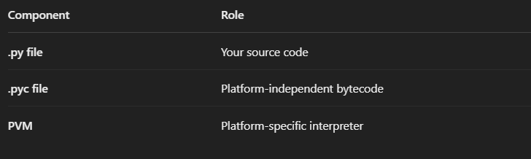

So, the magic lies in:

* Bytecode being universal
* PVM being customized per platform

That’s how Python = Write once, run anywhere ✅

## **✅ How to Install Python on Windows (Official Method)**

### **🔹 Step 1: Download Python**

1. Go to the **official Python website**:  
    👉<https://www.python.org/downloads/>
2. Click on the **latest version for Windows** Example: "Download Python 3.12.x"

### **🔹 Step 2: Run the Installer**

1. **Double-click** the downloaded .exe file.
2. 🟡 **Important! Before clicking "Install Now"**: ✅ **Check the box** that says:  
     
     
    🔲 **Add Python 3.x to PATH** This allows you to run Python from anywhere in your terminal.
3. Click **"Install Now"**

### **🔹 Step 3: Wait for Installation**

* Python will install along with **pip (Python package manager)**.
* Once done, click **“Close”**.

### **🔹 Step 4: Verify Installation**

1. Open **Command Prompt (cmd)**
2. Type:

python --version

➡️ You should see:

Python 3.12.x

1. Also try:

pip --version

➡️ Confirms that **pip** is also installed.

### **🔹 (Optional) Open IDLE or VS Code**

* You can search for **IDLE** (Python’s built-in editor) in the Start menu
* Or install **VS Code** for a better coding experience

### **🎯 You’re Ready to Go!**

Now you can start writing .py files and run them from:

* IDLE
* VS Code
* Command Line

## **❗ What If You Already Installed Python Without Adding to PATH?**

No worries! You can **add it manually**:

### **🔧 How to Add Python to PATH Manually (Windows)**

**Find Python installation path** Usually it's in:  
  
 C:\Users\<YourName>\AppData\Local\Programs\Python\Python3x\

1. Copy the full path, for example:  
     
     
   C:\Users\Gowtham\AppData\Local\Programs\Python\Python312\
2. Now do this:  
   * Search **"Environment Variables"** in Start
   * Click **“Edit the system environment variables”**
   * In the window, click **“Environment Variables…”**
   * In **System variables**, find **Path** → click **Edit**
   * Click **New**, then paste the Python path

C:\Users\<YourName>\AppData\Local\Programs\Python\Python3x\Scripts\

1. Click OK → OK → OK
2. Restart your Command Prompt

### **🧪 Test it:**

python --version

pip --version

If it works → you're good to go! 🚀

## **Step 1: Download PyCharm Community Edition**

1. **Visit the Official Download Page:**
   * Navigate to the [PyCharm Download page](https://www.jetbrains.com/pycharm/download/).
2. **Choose Your Operating System:**
   * The page will automatically detect your OS (Windows, macOS, or Linux). If not, select the appropriate tab for your system.
3. **Select the Community Edition:**
   * You'll see two options: **Professional** and **Community**. Under the **Community** section, click the **Download** button.

## **Step 2: Install PyCharm Community Edition**

**For Windows:**

1. **Run the Installer:**
   * Locate the downloaded .exe file (usually in your 'Downloads' folder) and double-click to run it.
2. **Follow the Installation Wizard:**
   * **Welcome Screen:** Click **Next**.
   * **Choose Install Location:** You can use the default location or specify a different folder. Click **Next**.
   * **Installation Options:**
     + *Create Desktop Shortcut:* (Optional) Check this box if you want a shortcut on your desktop.
     + *Update PATH Variable:* (Recommended) Check this to add PyCharm to your system PATH.
     + *Create Associations:* (Optional) Check this to associate .py files with PyCharm.
   * Click **Next** and then **Install**.
3. **Complete Installation:**
   * Once the installation is complete, you can choose to run PyCharm immediately or finish the setup.

**For macOS:**

1. **Open the Disk Image:**
   * Locate the downloaded .dmg file and double-click to open it.
2. **Install PyCharm:**
   * Drag the PyCharm icon into the **Applications** folder.
3. **Launch PyCharm:**
   * Navigate to your **Applications** folder and double-click the PyCharm icon to start the application.

**For Linux:**

1. **Extract the Tarball:**
   * Open your terminal and navigate to the directory containing the downloaded .tar.gz file.

Run the following command to extract:  
  
 tar -xzf pycharm-community-*.tar.gz -C /desired/installation/path/

1. **Run PyCharm:**

Navigate to the bin directory inside the extracted folder:  
  
cd /desired/installation/path/pycharm-community-*/bin

* + Run PyCharm using:  
      
    ./pycharm.sh

## **Step 3: Initial Configuration**

1. **Import Settings:**
   * **If you've previously used PyCharm and have settings to import, choose the appropriate option. Otherwise, select Do not import settings.**
2. **Customize UI (Optional):**
   * You can choose a theme (Light or Dark) and configure other UI settings as per your preference.
3. **Install Plugins (Optional):**
   * PyCharm may suggest installing additional plugins based on your development needs. You can choose to install them now or later.
4. **Create or Open a Project:**
   * Once the initial setup is complete, you can create a new project or open an existing one to start coding.

### 

### 

### **About the Author**

**Gowtham SB** is a **Data Engineering expert, educator,** **and content creator** with a passion for **big data technologies, as well as cloud and Gen AI** . With years of experience in the field, he has worked extensively with **cloud platforms, distributed systems, and data pipelines**, helping professionals and aspiring engineers master the art of data engineering.

Beyond his technical expertise, Gowtham is a **renowned mentor and speaker**, sharing his insights through engaging content on **YouTube and LinkedIn**. He has built one of the **largest Tamil Data Engineering communities**, guiding thousands of learners to excel in their careers.

Through his deep industry knowledge and hands-on approach, Gowtham continues to **bridge the gap between learning and real-world implementation**, empowering individuals to build **scalable, high-performance data solutions**.

𝐒𝐨𝐜𝐢𝐚𝐥𝐬

🎥𝐘𝐨𝐮𝐓𝐮𝐛𝐞 - https://www.youtube.com/@dataengineeringvideos

📸𝐈𝐧𝐬𝐭𝐚𝐠𝐫𝐚𝐦 - <https://instagram.com/dataengineeringtamil>

📸𝐈𝐧𝐬𝐭𝐚𝐠𝐫𝐚𝐦 - [https://instagram.com/](https://instagram.com/dataengineeringtamil)thedatatech.in

🤝𝐂𝐨𝐧𝐧𝐞𝐜𝐭 𝐟𝐨𝐫 𝟏:𝟏 - https://topmate.io/dataengineering/

💼𝐋𝐢𝐧𝐤𝐞𝐝𝐈𝐧 - https://www.linkedin.com/in/sbgowtham/

🌐𝐖𝐞𝐛𝐬𝐢𝐭𝐞 - https://codewithgowtham.blogspot.com

💻𝐆𝐢𝐭𝐇𝐮𝐛 - http://github.com/Gowthamdataengineer

💬𝐖𝐡𝐚𝐭𝐬 𝐀𝐩𝐩 - https://lnkd.in/g5JrHw8q

📧𝐄𝐦𝐚𝐢𝐥 - atozknowledge.com@gmail.com

📱𝐀𝐥𝐥 𝐌𝐲 𝐒𝐨𝐜𝐢𝐚𝐥𝐬 - <https://lnkd.in/gf8k3aCH>